Project Design Phase-II
Technology Stack (Architecture & Stack)

Date | 6 July 2026
Team ID
Project Name | ShopEz E-Commerce Application
Maximum Marks | 4 Marks

Technical Architecture:
The ShopEz E-Commerce Application follows a MERN Stack architecture, where the React.js frontend communicates with the Node.js and Express.js backend through REST APIs. The backend manages user authentication, product inventory and catalog management, price computation, and order milestone tracking, while MongoDB Atlas securely stores user, product, cart, order, and configuration data. The technical architecture diagram and the information in Table 1 and Table 2 illustrate the application's components, technologies, infrastructure, and data flow.
Example: Premium ShopEz E-Commerce and Inventory Management System
Reference: https://developer.ibm.com/patterns/ai-powered-backend-system-for-order-processing-during-pandemics/
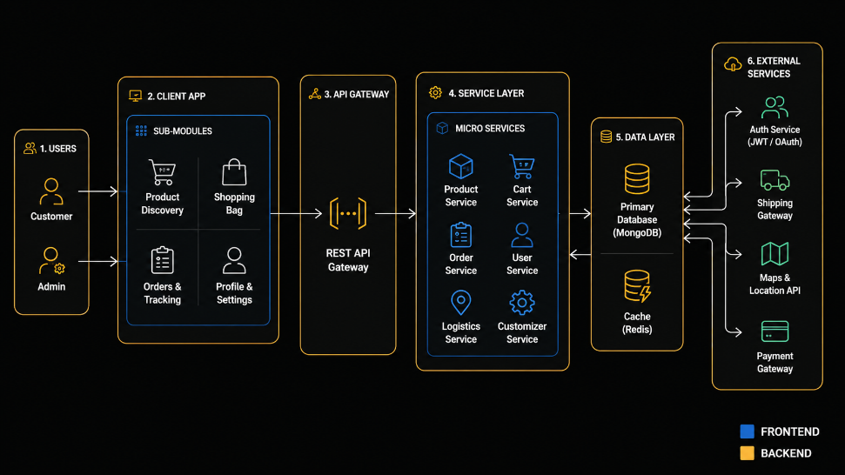
Guidelines:
- Include the complete application workflow, infrastructure (Local/Cloud), external APIs (Google Maps, Payment Gateway), and MongoDB database components in the solution architecture.
- Clearly illustrate the interaction between the frontend, backend, database, and third-party services; machine learning is not applicable in the current version.

Table-1 : Components & Technologies:
S.No | Component | Description | Technology
 | User Interface | Web application for Customers and Admin | HTML5, CSS3, JavaScript, React.js
 | Application Logic-1 | User Authentication & Authorization | Node.js, Express.js, JWT, bcrypt
 | Application Logic-2 | product Inventory & Catalog Management | Node.js, Express.js
 | Application Logic-3 | Price Computation & Order Milestone Tracking | JavaScript, Express.js
 | Database | Stores Users, Products, Carts, Orders & Configs | MongoDB
 | Cloud Database | Cloud-hosted database service | MongoDB Atlas
 | File Storage | Product catalog listing images and mockups | Local Storage / Cloudinary
 | External API-1 | Not Applicable | N/A
 | External API-2 | Payment Gateway | Razorpay / Stripe
 | Machine Learning Model | Not Applicable | N/A
 | Infrastructure (Server/Cloud) | Backend API Hosting | Node.js Server, Render / Railway / Localhost

Table-2: Application Characteristics:
S.No | Characteristics | Description | Technology
- 1 | Open-Source Frameworks | Frameworks used for application development | React.js, Node.js, Express.js, MongoDB
- 2 | Security Implementations | Secure Login, Password Encryption & JWT Authentication | bcrypt, JWT, HTTPS
- 3 | Scalable Architecture | MERN Stack supports future growth and multiple users | React.js, Express.js, MongoDB
- 4 | Availability | Application available 24×7 through cloud deployment | MongoDB Atlas, Render
- 5 | Performance | Fast API response and optimized database queries | Express.js, MongoDB Indexing

References:
https://c4model.com/
https://developer.ibm.com/patterns/online-order-processing-system-during-pandemic/
https://www.ibm.com/cloud/architecture
https://aws.amazon.com/architecture
https://medium.com/the-internal-startup/how-to-draw-useful-technical-architecture-diagrams-2d20c9fda90d

